**MA4413 R Assignment**

**Graphical and numerical summaries**

The histogram for cpu1:

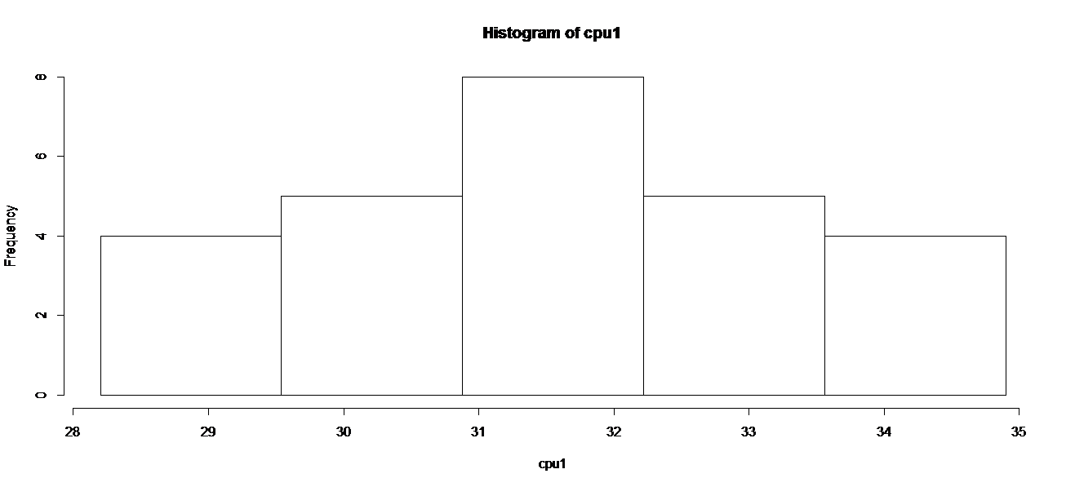

is normally distributed where as the histogram for cpu2:

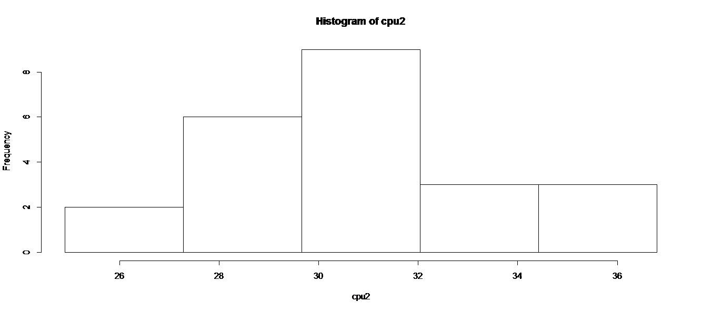

is skewed to the right.

The boxplots:

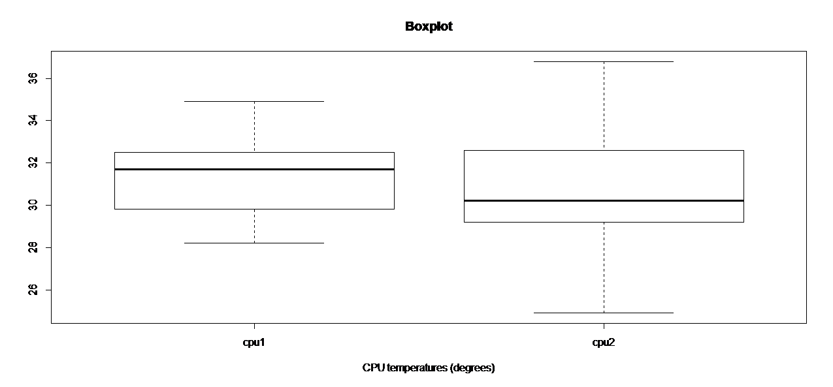

show that cpu1 is skewed to the left and cpu2 is skewed to the right. If you compare the mean to the median they support this ie. for cpu1 the mean is less than the median and for cpu2 the mean is greater than the median. The average temperature in cpu1 is higher than in cpu2. The temperatures in cpu2 vary more compared to cpu1. Cpu2 has a larger maximum temperature and a smaller minimum temperature compared to cpu1

**Normality of Data**

The qqplots:

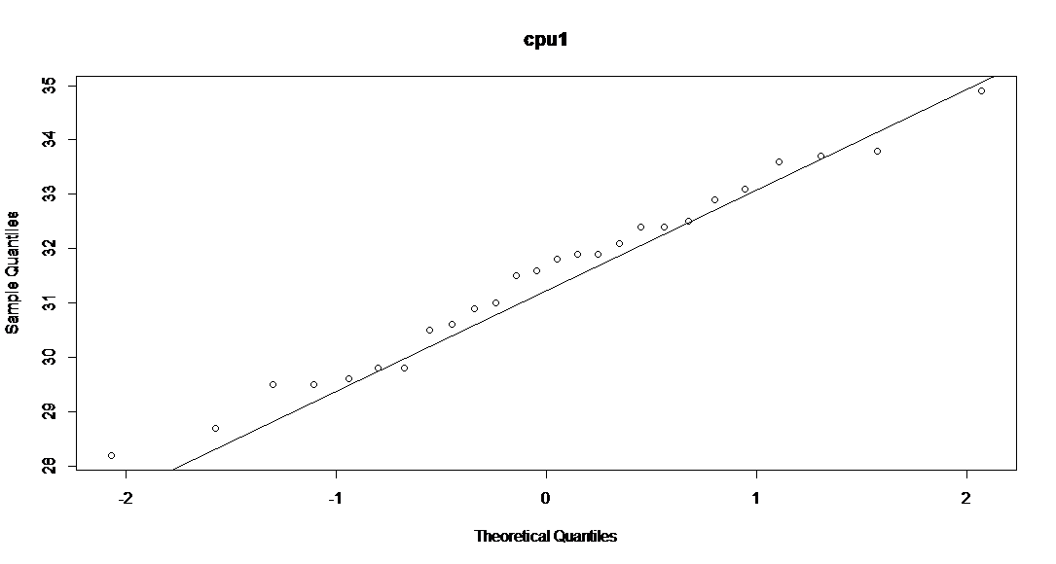

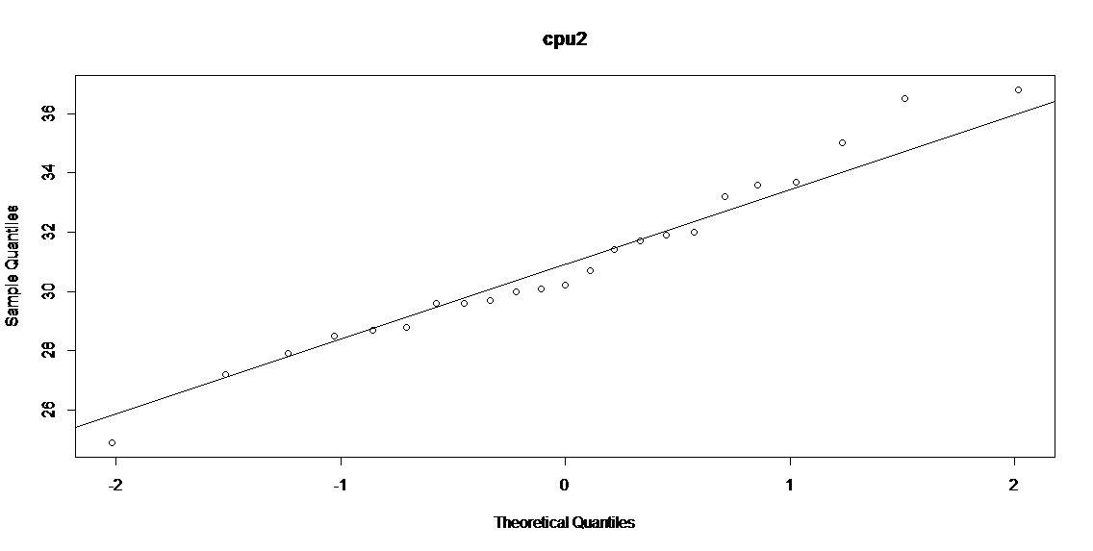

show that both cpu's can be seen to not be normally distributed especially cpu2. You can also see this in both the histograms and the boxplots.

**Shapiro - Wilk test**

> shapiro.test(cpu1)

Shapiro-Wilk normality test

data: cpu1

W = 0.9818, p-value = 0.9088

> shapiro.test(cpu2)

Shapiro-Wilk normality test

data: cpu2

W = 0.9741, p-value = 0.7852

Null Hypothesis: The set of data is normally distributed

Alternative Hypothesis: The set of data is not normally distributed

The test results show that neither sets are normally distributed due to the value of W being greater than the p-value in both tests.

**Difference between population means**

**The F Test**

var.test(cpu1,cpu2)

F test to compare two variances

data: cpu1 and cpu2

F = 0.3414, num df = 25, denom df = 22, p-value = 0.01075

alternative hypothesis: true ratio of variances is not equal to 1

95 percent confidence interval:

0.1471806 0.7746756

sample estimates:

ratio of variances

0.3414224

Null Hypothesis: That both data sets have equal variance

Alternative Hypothesis: That both data sets don't have equal variance

The results of the f test show us that the data sets don't have equal variance due to p-value being less than 0.05.

**The T Test**

t.test(cpu1, cpu2,var.equal=FALSE)

Welch Two Sample t-test

data: cpu1 and cpu2

t = 0.758, df = 34.525, p-value = 0.4536

alternative hypothesis: true difference in means is not equal to 0

95 percent confidence interval:

-0.8830109 1.9345159

sample estimates:

mean of x mean of y

31.46923 30.94348

Null Hypothesis: That the means of both data sets are equal

Alternative Hypothesis: That the means of both data sets are not equal

We accept our null hypothesis as p = 0.4536 which is much higher than our significance level of 0.05

**Wilcoxon rank-sum test**

> wilcox.test(cpu1,cpu2)

Wilcoxon rank sum test with continuity correction

data: cpu1 and cpu2

W = 348.5, p-value = 0.3261

alternative hypothesis: true location shift is not equal to 0

Warning message:

In wilcox.test.default(cpu1, cpu2) : cannot compute exact p-value with ties

Null Hypothesis: That the mean of both data sets are equal

Alternative Hypothesis: That the mean of both data sets are not equal

We accept our null hypothesis as p = 0.3261 which is much higher than our significance level of 0.05.

**Conclusion**

The temperatures for cpu1 are less varied compared to cpu2. Neither cpu's are normally distributed but cpu1 is quite close to being normally distributed. Cpu1 and cpu2 do not have equal variance. We have don't have enough data not to accept that they have equal means.

**Outcome**

I would say that the design for cpu1 is better due to the temperatures varying less and being more consistent. The both have equal means but cpu2 has a larger IQR and standard deviation.